Lesson 4.0: Vees.(Neutral decay)

Introduction to the teacher:
This lesson begins with a photo of a bubble chamber interaction. The picture shows a collision followed by a so-called vee. Students will begin by simply describing what they see in the photo, using what they have learnt during the first three lessons. The students will then concentrate on the vee. By using conservation of charge and conservation of momentum, students will be able to infer the most basic facts about vees.

The interaction:

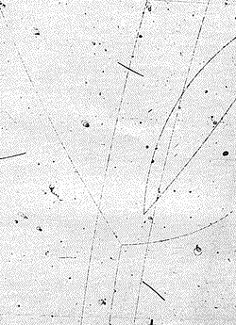

Prior knowledge required for this lesson:
Knowledge of basic physics required for understanding lessons 1-3.
The ability to read bubble chamber pictures like those presented in lessons 1–3.

Objectives:

Students will understand the following:
The decay of neutral particles
Application of conservation laws to analyze particle interactions
Students will be able to do the following:
Use photos of particle tracks from bubble chamber experiments to identify more complex collisions and decays.
Apply conservation of charge quantitatively and conservation of momentum qualitatively to particle interactions.
Identify the origin of neutral particles in bubble chamber photos.
Classify bubble chamber events.

Suggested lesson introduction:

Students see a projection or drawing of the photo showing a neutral particle forming a ‘vee’.

Teaching strategy:

- Looking at the picture

Ask students to describe what they see. What story does the picture tell?
Is there anything familiar in the picture, anything new?

- Possible discussion points:
What can we say about the two tracks that start at a common vertex, but which have no tracks coming in to it?
Students should be able to tell from the photo that the two tracks curve in opposite directions, and infer that this means the particles have opposite charges.
What could be the origin of these two tracks?
From what they have learnt about the tracks of neutral particles, students should be able to tell that a neutral particle must have come in towards the vertex in question.
Where could this neutral particle come from?
By tracing the invisible track backwards, students should be able to locate the origin of the neutral particle.

- Conclusion:
‘Vee’ is the term used for the decay of neutral particles.
Now that we have learned how to recognize collisions, kinks and vees in bubble chamber pictures, we can classify events from the number of each of these features. We do this by counting the number of tracks leaving the interaction point (so-called prongs) and the number of kinks and vees in the event. An event with 4 prongs, 1 kink and 2 vees, is classified as a 412 event.

Sample exercises:

- Try to identify the vees in the following pictures (LINKS).
- Try to find out where in the photo the neutral particle is coming from.
- Find out what happened there.
- Classify the event in the picture according to the number of prongs, kinks and vees. Do the same for all the pictures you have examined so far in the lessons.

