ACTIVITY 1

On the web: http://public.web.cern.ch/public/Content/Chapters/Spotlight/SpotlightAandD-en.htm Sportlight on Dan Brown’s book “Angels and Demons”

ANTIMATTER BOMB

TRUE OR FALSE ?

Is an antimatter bomb 100 times more deadly than an atom bomb?

Is antimatter 100% efficient?

Can you contain antimatter with electric fields?

Is it possible to get 1 gr of antimatter?

How much air can there be in an antimatter bomb?

Can the container be about 10 Kg?
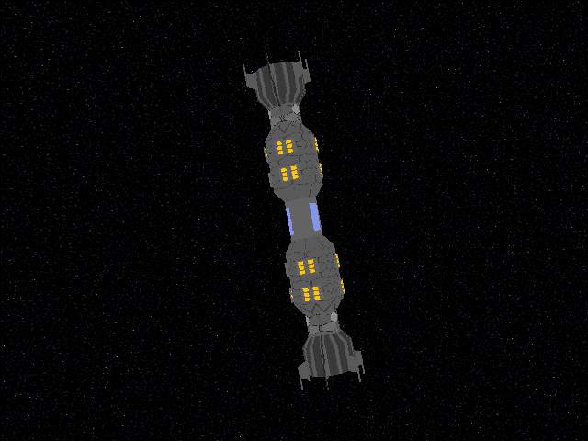
Can antimatter solve the energy problem?

