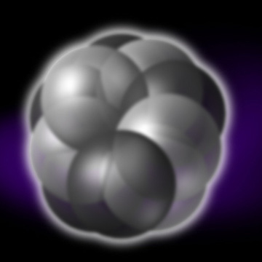 | 0.1 meter = 10 cm This power of 10 is 10 cm.  A close look at the fly on the leaf of a rose tree
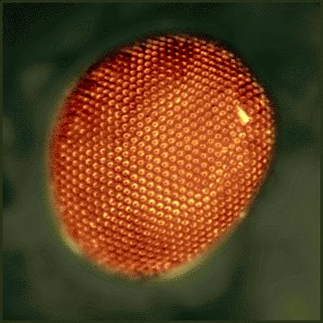 | 10-3 meter = 1 mm This power of 10 equals to 1 mm. We just see the eye of the fly.
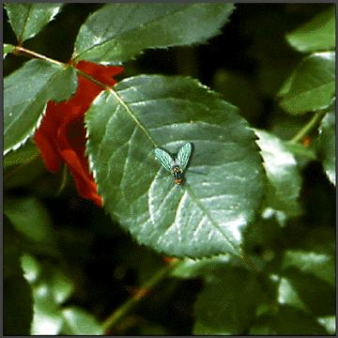 | 10-5 meter = 10 microns This power of 10 equals to 10 microns. We can now see a hair on the eye of a fly.
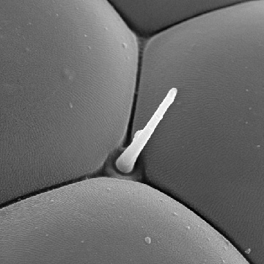 | 10-7 meter = 0.1 micron  This power of 10 equals to 0.1 micron. Now, the base of the hair and cells that make the eye of the fly are revealed.
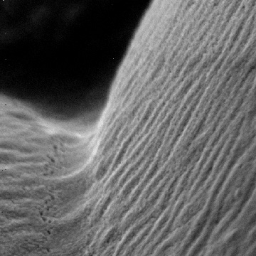 | 10-14 meter = 10 fermis  This power of 10 equals to 10 fermis (10-14 meters). We see the nucleus of a carbon atom.
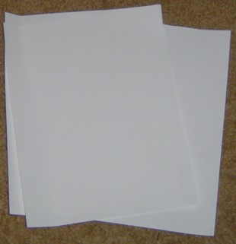 | 10??? Meter how thick is a sheet of paper?

Could you measure how thick a sheet of paper is?
Answers at http://microcosm.web.cern.ch/Microcosm/P10/english/P0.html

