Atoms are constructed of two types of elementary particles: electrons and quarks. We say that one particle is elementary when it is not made from other particles
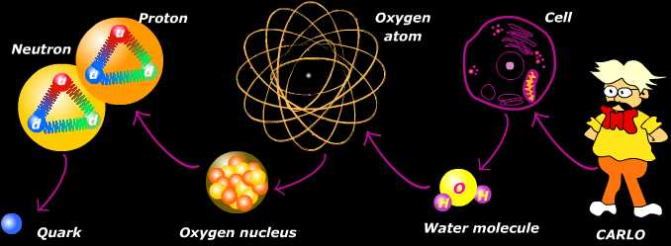

Electrons occupy a space that surrounds an atom's nucleus. Each electron has an electrical charge of -1.
Quarks make up protons and neutrons, which, in turn, make up an atom's nucleus. Each proton and each neutron contains three quarks.
A quark is a fast-moving point of energy. There are several varieties of quarks. Protons and neutrons are composed of two types: up quarks and down quarks. Each up quark has a charge of +2/3. Each down quark has a charge of -1/3. The sum of the charges of quarks that make up a nuclear particle determines its electrical charge.

Protons | Neutrons
two up quarks and one down quark. | one up quark and two down quarks.
+2/3 +2/3 -1/3 = +1 | +2/3 -1/3 -1/3 = 0
Stable atom has a net charge of 0. In other words, it has an equal number of protons and electrons. The positive protons cancel out the negative electrons.

The atoms needs also to hold together protons and neutrons The strong force counteracts the tendency of the positively charged protons to repel one another. It also holds together the quarks that make up the protons and neutrons. An atom becomes radioactive (which means that is unstable and may lose particles) when its nucleus contains too many or too few neutrons: the number of protons and neutrons at the nucleus must be balanced too.

