Activities

- Choose the right answers. There is always at least one right answer, but it could be more than one.
  - Protons and neutrons are the elementary particles of the nucleus
  - If you break a neutron you will obtain three quarks
  - The electrical charge of nucleus must be 0

- Two quarks up and one quark down, makes…
a. One proton
b. One neutron
c. One electron

- One electron and one proton…
  - Annihilates each other
  - Have opposite charges
  - Are elementary particles from the atom
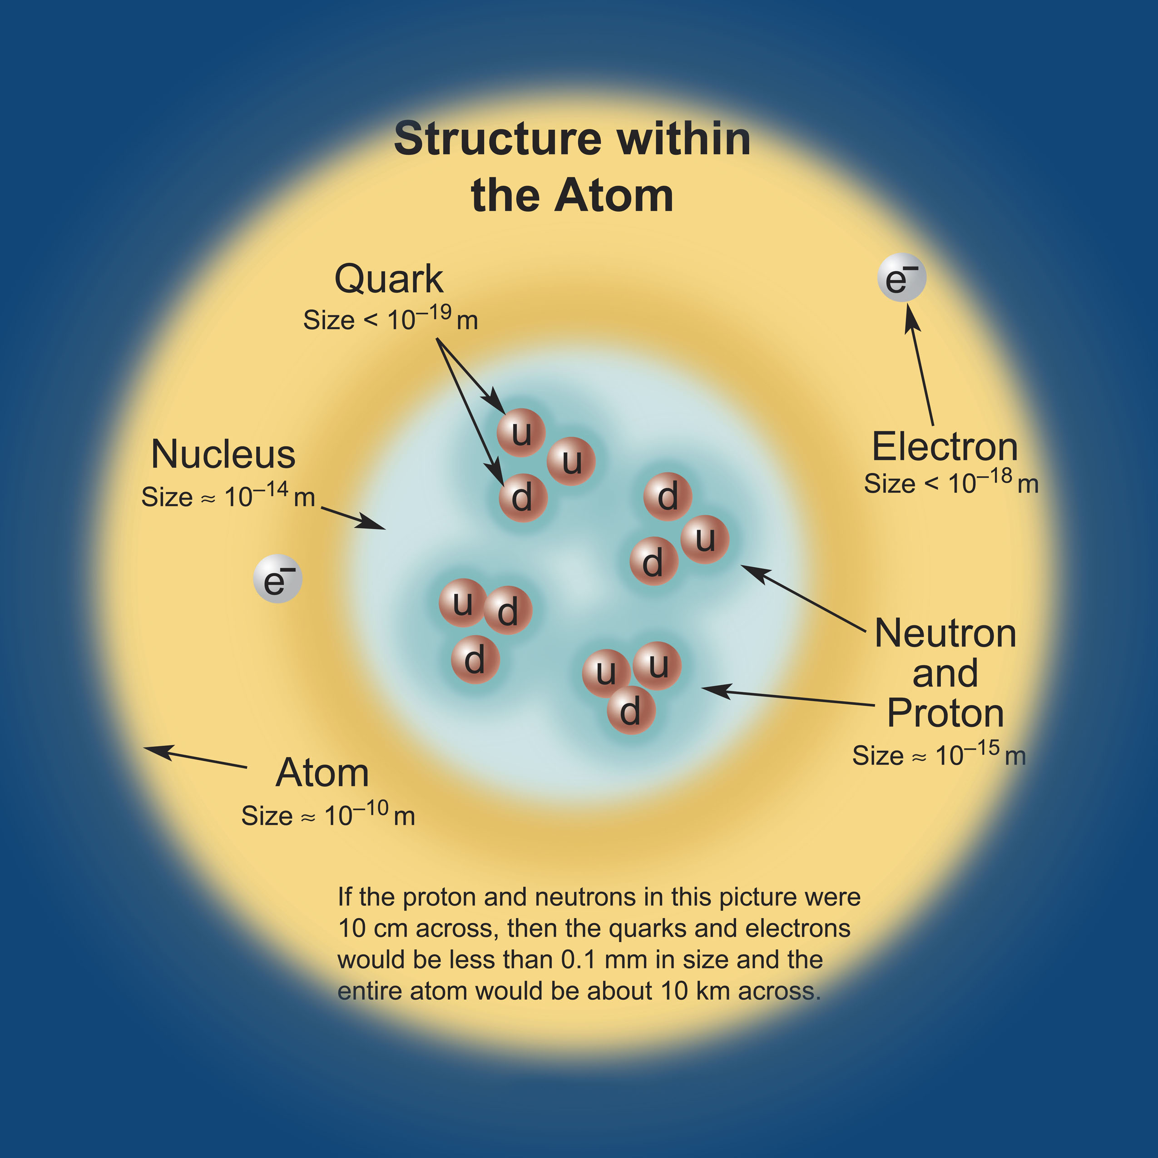
3. Look at the following image and complete the missing words

A Helium nucleus has two protons and two _________.

Each proton is made from _________ quarks. The electrical net charge of the Helium nucleus is ____.

The electrical net charge of the whole atom is __________

If we add or remove one ______ to the nucleus, the atom becomes radioactive.

