ELECTRON DIFFRACTION

1. AIM

The aim of this experiment is to determine the interplanar spacing of graphite from the relationship between the radius of the diffraction rings and the wavelength, by using de Broglie equation and Bragg’s diffraction.
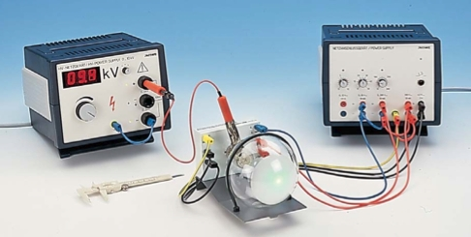
According to wave-particle duality, electrons have both wave and particle behaviors that will show up depending on the aim of the experiment (i.e., experiment measuring particle properties will not have the wave behavior showing up and vice versa).
From de Broglie equation, fast electrons have high momentum and hence a wavelength comparable to the spacing between layers in a crystal. These electron waves can undergo Bragg’s reflection and interfere. Making use of the wave behavior of electrons, fast electrons are diffracted from a polycrystalline layer of graphite and interference rings appear on a fluorescent screen. The interplanar spacing in graphite is determined from the diameter of the rings and the accelerating voltage.

2. THEORETICAL BACKGROUD

To explain the interference phenomenon, a wavelength λ, which depends on momentum p, is assigned to the electrons in accordance with the de Broglie equation:
$$λ=\frac{h}{p}$$
where h = 6.625·10^{–34} Js is the Planck’s constant. The momentum can be calculated from the kinetic energy that the electrons acquire under acceleration voltage V:
$$K=\text{ eV }⇒ \frac{p^{2}}{2m}=\text{ eV }⇒\text{ p }=\sqrt{\text{2meV}}$$
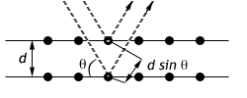
The wavelength is thus
$$λ=\frac{h}{\sqrt{\text{2meV}}}$$
where e = 1.602·10^{–19} As (the electron charge) and
m = 9.109·10^{–31} kg (rest mass of electron).
At the voltages V used, the relativistic mass can be Fig. 1: Bragg’s reflection
replaced by the rest mass with an error of only 0.5%.
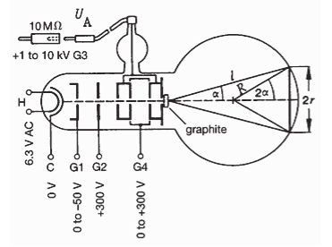
The electron beam strikes a polycrystalline graphite film deposite on a copper grating and is reflected in accordance with the Bragg condition (derived by the English physicists Sir W.H. Bragg and his son Sir W.L. Bragg in 1913 to explain why the cleavage faces of crystals appear to reflect X-ray beams at certain angles of incidence):
2d∙sinθ = n∙λ, n = 1, 2, … Fig. 2: Electron diffraction tube
where d is the spacing between the planes of the carbon atoms and θ is the Bragg angle (angle between electron beam and lattice planes). In polycrystalline graphite, the bond between the individual layers (Fig. 3) is broken so that their orientation is random. The electron beam is therefore spread out in the form of a cone and produces interference rings on the fluorescent screen. The Bragg angle θ can be calculated from the radius of the interference ring but it should be remembered that the angle of deviation α (Fig. 2) is twice as great:
α = 2θ Fig. 3: Crystal lattice of graphite.
From Fig. 2 we read off
sin(2α) = r / R
where R = 65 mm is the radius of the glass bulb.
Now,
sin(2α) = 2sinα∙cos α
and for small angles α (cos 10º = 0.985) we can put
sin(2α) ≅ 2sinα ⇒ sinα ≅ sin(2α) / 2 ⇒ sinα ≅ r / 2R.
For small angles θ we obtain
sinα = sin(2θ) ≅ 2sinθ ⇒ sinθ ≅ sinα / 2 ⇒ sinθ ≅ r / 4R.
With this approximation we obtain
2d∙r / 4R = n∙λ, n = 1, 2, … ⇒ r = n(2R/d)∙λ, n = 1, 2, …
Thus, if we measure r for various λ (that is, various V) and then plot r versus λ, we obtain a line with a slope of n(2R/d).
The two inner interference rings occur through reflection from the lattice planes of spacing d₁ and d₂ (Fig. 4), for n = 1. Thus the slope is 2R/d.

3. SETUP
3.1. Equipment
- Electron diffraction tube on mounting
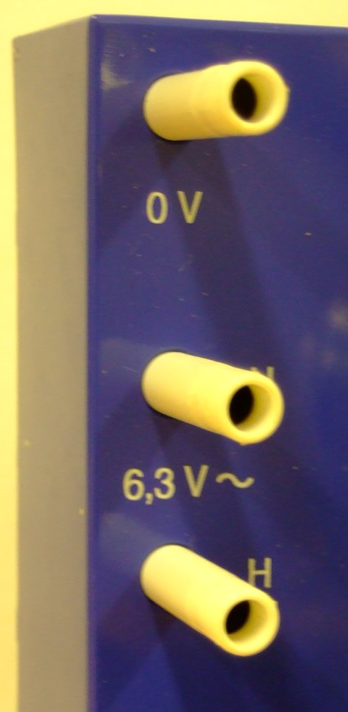 | 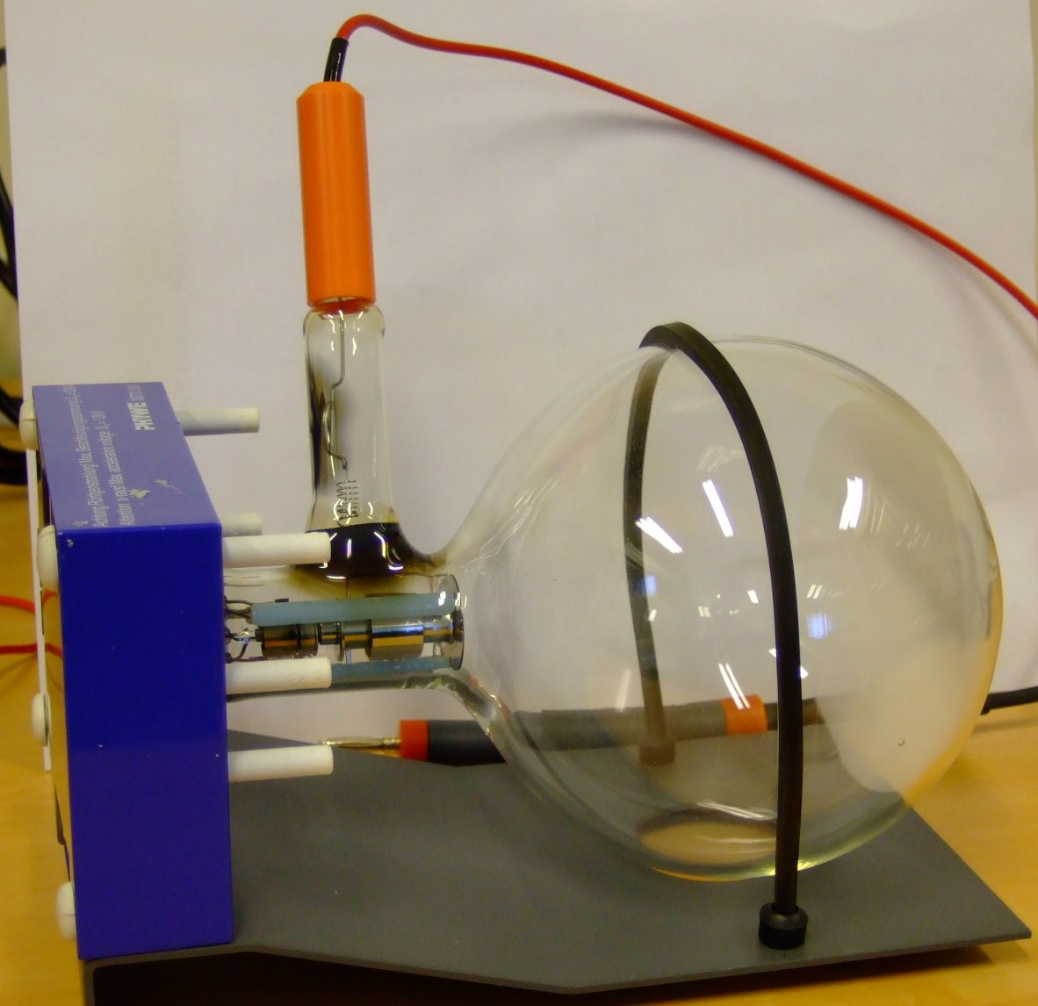 | 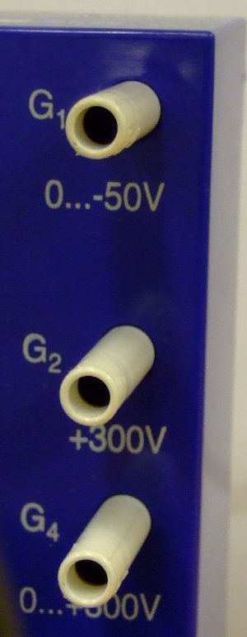
Left mounting | Electron diffraction tube | Right mounting
- High voltage supply unit, 0 – 10 kV
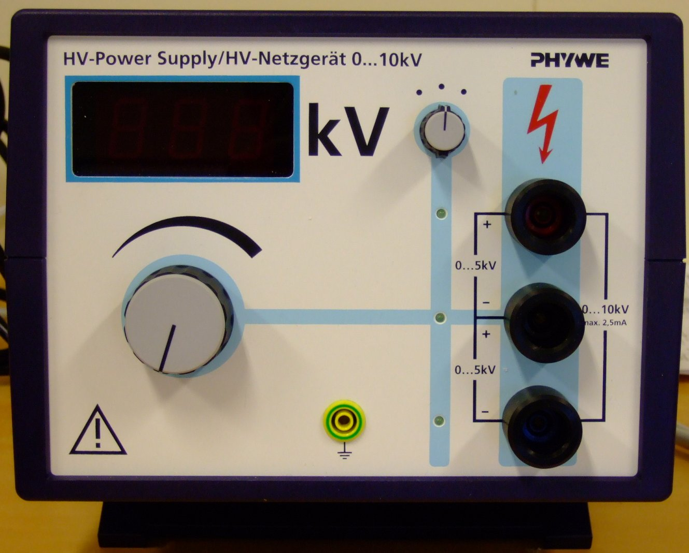

- Connecting cord, 30 kV (with High-value resistor, 10 MΩ)
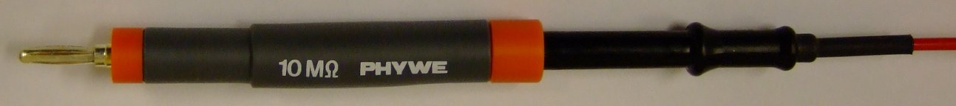

- DC Power supply, 0 – 600 V
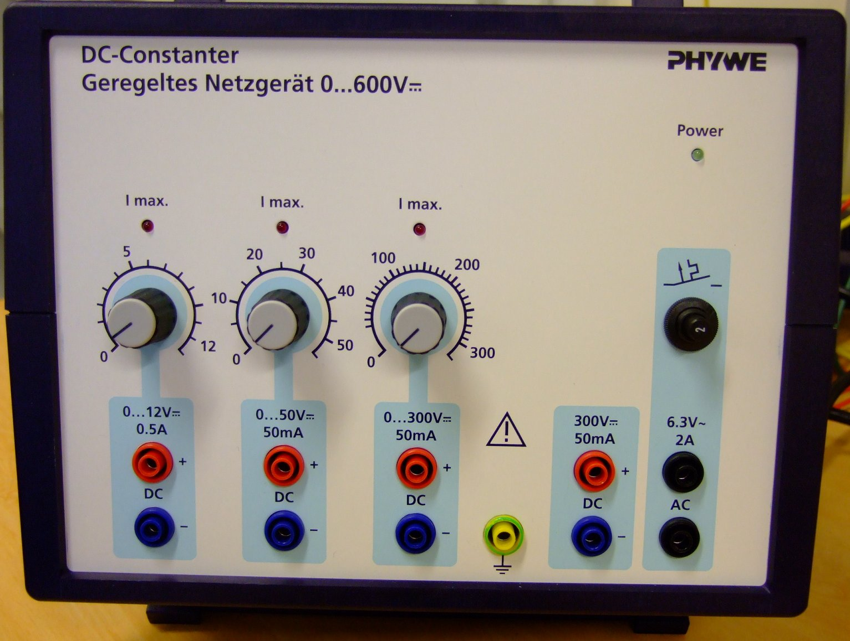
- Vernier calipers
- 6 connecting cords

3.2. Assembling the experiment
Fig. 1: Complete setup of experiment

- Setup the experiment as shown in Fig. 1.
- Connect the sockets of the electron diffraction tube to the power supply as shown in Fig. 2. The power supplies are shown in Fig. 3. The complete setup is shown in Fig. 1.
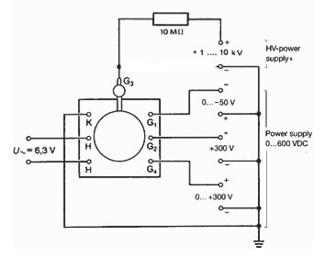
Fig. 2: Circuit diagram to connect electron diffraction tube to power supply
d.c. power supply High voltage supply
Fig. 3: d.c. and high voltage supply

- Connect the high voltage to the anode G3 through a 10 MΩ protective resistor as shown in Fig. 4
Fig. 4: Schematic diagram showing how the electron diffraction tube is connected to power supply

3.3. Safety precautions
- This setup used relatively high current. Care should be taken when conducting the experiment.
- The bright spot just in the center of the screen can damage the fluorescent layer of the tube. To avoid this reduce the light intensity after each reading as soon as possible.
3.4. Experimental procedure
- Set the voltage of G1 to -50 V using the second knob on the dc power supply (or whatever value the beam is bright enough).
- Set the voltage of G4 to about 0 V using the third knob on the dc power supply (or whatever value that make the beam is sharp enough).
- Slowly increase the high voltage supply until the ring structure appears on the fluorescent layer on the electron diffraction tube. The visibility of high order rings depends on the light intensity in the laboratory and the contrast of the ring system which can be influenced by the voltages applied to G1 and G4. Rings should appear when the voltage is about 4 kV.

D₁ – Diameter of 1st ring
D₂ – Diameter of 2nd ring
D₁
D₂

Fig. 4: Ring system appearing on the fluorescent layer

- Start with a low voltage, measure the diameters D₁ and D₂ of the first and second ring using the vernier calipers. Record the voltage reading and the diameters of the rings
- Repeat the same measurements for higher voltages to about 10 – 11 kV.
- Work out the wavelength λ of the electron beam using $λ=\frac{h}{\sqrt{2m_{e}\text{eV}}}$ where m_{e} is the mass of the electron, e is the elementary charge and V is the value of the high voltage supply.
- Find the radii of the 1st and 2nd rings for the different applied voltage.
- Plot a graph of r₁ and r₂ against λ. The gradients of the lines is equal to $\frac{2R}{d_{1}}$ and $\frac{2R}{d_{2}}$ respectively where R is the radius of the glass bulb (6.5 cm) and d_{i} is the lattice plane spacing of graphite depending on the incident beam direction to the graphite lattice.

4. SOME GUIDANCE TO TEACHERS

- Fig. 5 shows a sample data of the experiment.
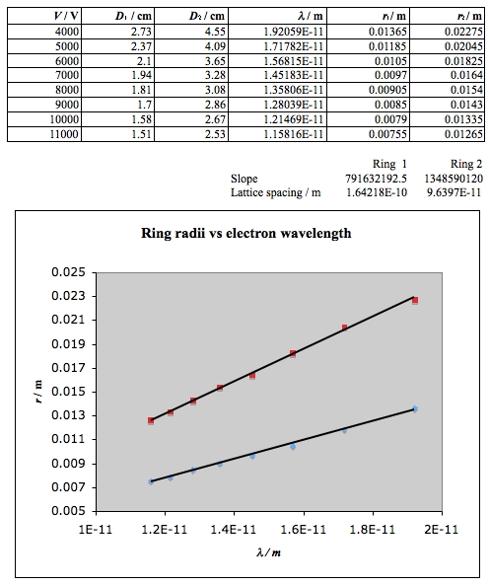
Fig. 5: Sample experimental data
- It can be seen that the margin of error (d₁ = 164 pm vs 213 pm, d₂ = 96 pm vs 123 pm) may be large due to the fact that the diameter measurement is difficult and not very accurate.
- This experiment involves two important concepts in modern physics – de Broglie relationship and Bragg’s reflection. It may be used to demonstrate wave-particle complementary and application of Bragg’s reflection.
- As the applied voltage increases, the rings become brighter. One can see that there are additional rings which correspond to either higher order or other lattice plane spacing. Teachers may choose to elaborate on Bragg’s conditions or simply gross over depending on the level of confidence of the class.

