BRAUN’S TUBE (CATHODE RAY TUBE)

1. PURPOSE

The Braun’s tube is designed for demonstrating the operation of an oscilloscope tube. The path of the electrons in the tube filled with a low pressure rare gas can be observed in a darkened room as a trace of light. Electron beam deflection can be effected by means of either an electrical or a magnetic field

2. HISTORICAL AND THEORETICAL BACKGROUND

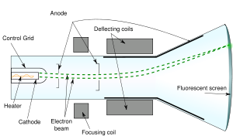
The Braun’s or cathode ray tube (CRT), invented by German physicist Karl Ferdinand Braun in 1897, is an evacuated or low press gas glass envelope containing an electron gun (a source of electrons) and a fluorescent screen, usually with internal or external means to accelerate and deflect the electrons. When electrons strike the fluorescent screen, light is emitted.
The electron beam is deflected and modulated in a way which causes it to display an image on the screen. The image may represent electrical waveforms (oscilloscope), pictures (television, computer monitor), echoes of aircraft detected by radar, etc.
Fig.1: Cathode Ray Tube - Diagram
The source of the electron beam is the electron gun, which produces a stream of electrons through thermionic emission, and focuses it into a thin beam. The gun is located in the narrow, cylindrical neck at the extreme rear of a CRT and has electrical connecting pins, usually arranged in a circular configuration, extending from its end. These pins provide external connections to the cathode, to various grid elements in the gun used to focus and modulate the beam, and, in electrostatic deflection CRTs, to the deflection plates. Since the CRT is a hot-cathode device, these pins also provide connections to one or more filament heaters within the electron gun. When a CRT is operating, the heaters can often be seen glowing orange through the glass walls of the CRT neck. The need for these heaters to 'warm up' causes a delay between the time that a CRT is first turned on, and the time that a display becomes visible. In older tubes, this could take fifteen seconds or more. The electrodes are often covered with a black layer, a patented process used by all major CRT manufacturers to improve electron density.

- SAFETY PRECAUTIONS

• Carefully read these operating instructions completely before operating these instruments. This is necessary to avoid damage to it, as well as for user-safety.
• Only use the instruments for the purpose for which it was designed.
• Do not start up these instruments in case of visible signs of damage to it or to the line cord.
• Do not exert mechanical force on the tube.
• The Power supply for Braun tube and the Power supply, 0...600 VDC, supplies voltages that are dangerous to contact and is therefore only to be operated under expert supervision. In particular, the circuitry (experimental set-up) is first to be completely set up and be re-checked in currentless condition (absolute disconnection from the mains, mains plug unplugged!) before the instruments are connected to the mains and switched on.

4. EXPERIMENTAL SETUP
Fig.2: Circuit diagram

4.1 LIST OF ACCESSORIES
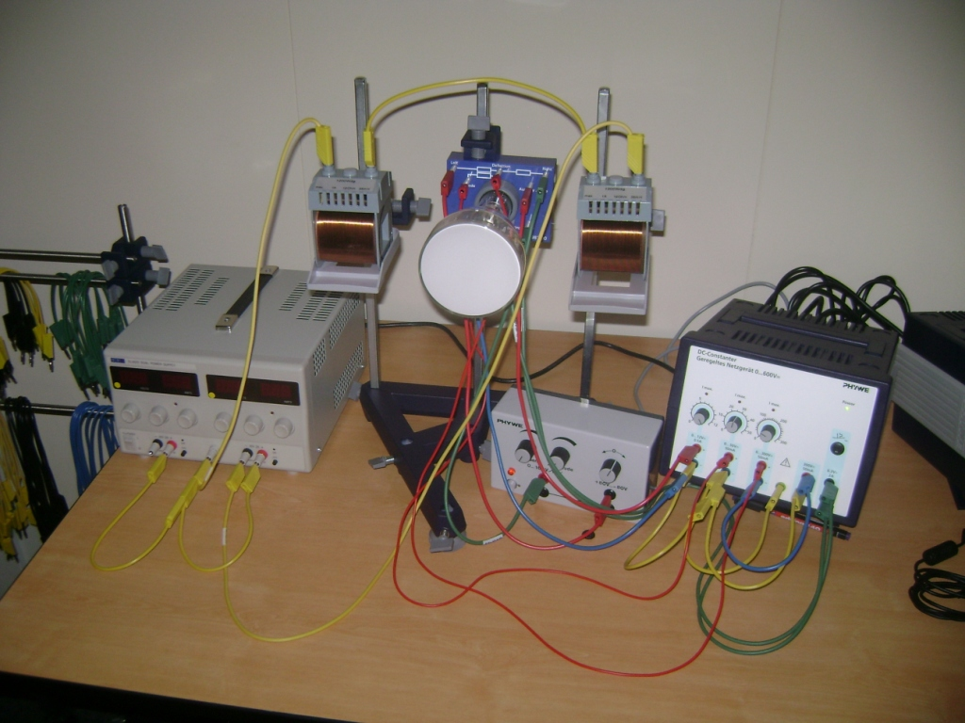
- Braun’s tube (06987.00)
- Power supply for Braun tube (06986.93)
- Power supply, 0...600 VDC (13672.93)
- Coil, 1200 turns (2x) (06515.01)
- Coil holder (2x) (06528.00)
- Support base „PASS“ (02005.55)
- Support rod „PASS“, square,
l = 400 mm (3x) (02026.55)
- Right angle clamp „PASS“ (3x) (2040.55)
- Connecting cord, safety
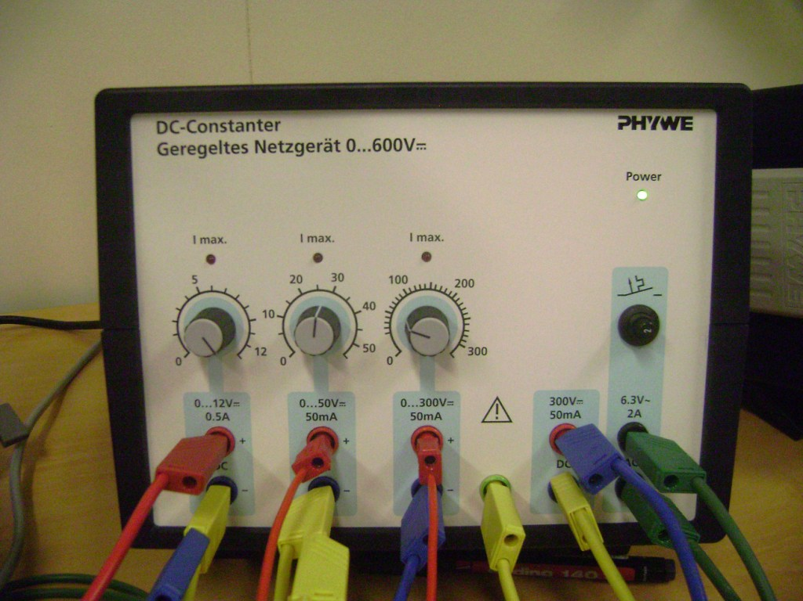
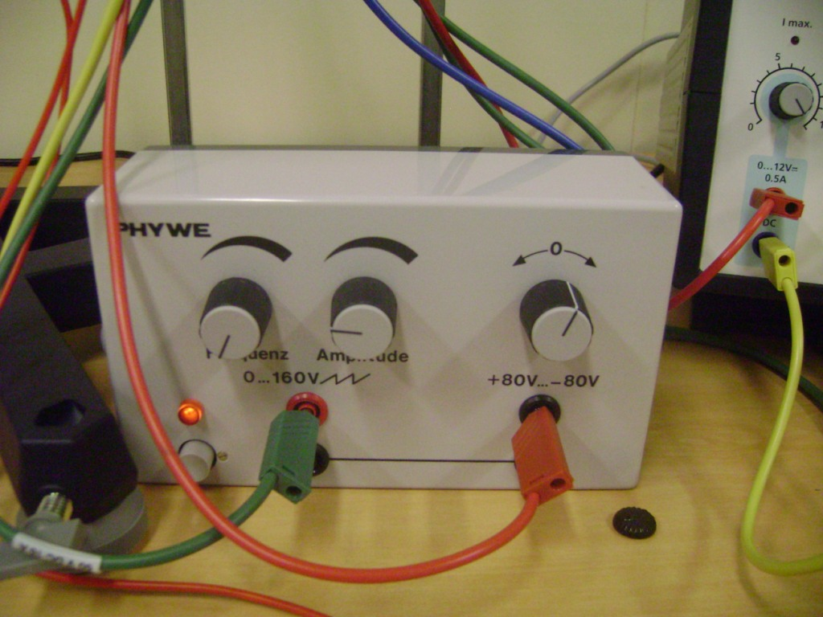

Photographs of the experimental device, the power supply and the operation unit

4.2 SETUP PROCEDURE
Fig.3: The circuit
Fig. 2 illustrates the cathode ray tube wiring circuit. All operating voltages can be taken from power supply (13672.93). 30...50 V is a suitable anode voltage. For post acceleration voltage to the deflector plates, outputs “0 ...300 VDC” and “300 VDC” are switched in series and the voltage taken is applied to the point of symmetry of the high impedance resistance circuit between the deflector plates.
To achieve electrical deflection of the electron beam and to write a time base,
the deflector plate connections are connected to the two upper sockets on the power pack( 06986.93); The right hand deflector plate is connected to the red socket, while the left hand deflector is connected to the black socket.
To achieve a magnetic deflection of the electron beam setting two series connected coils, 1200 winding, on a coil holder which (possibly with the aid of clamping columns) can be secured to retort stands; the common coil axis should intersect the cathode ray tube between the anode and deflector plates (Fig. 3)

5. EXPERIMENTAL PROCEDURE
- The voltage at the auxiliary anode should be such as to give a clearly visible light spot (approx. 8-10 V).
- We can change the horizontal position of the light spot by adding a tension (-80V…+80V) to the left deflection plate.
- The electron beam will wander from the left to right when writing the time base if we add tension to the right plate. We can change the frequency and the width of this tension.
- Magnetic deflection of the electron beam can be demonstrated by approaching the pole of a bar magnet to the cathode ray tube. As it is shown on the photograph we can provide magnetic field to the tube by using another power supply. The tension that this device provides is DC, so the deflection caused to the light spot is standing and perpendicular.
- It is possible to produce a set-up for periodic deflection of the electron beam with the aid of an alternating magnetic field, setting two series connected coils, 1200 winding, on a coil holder which (possibly with the aid of clamping columns) can be secured to retort stands; the common coil axis should intersect the cathode ray tube between the anode and deflector plates.

